ITP4940 IP Switched Networks Implementation
Written Test Preparation

Q1 | This question is related to Network Design Fundamentals.
 | (a) | Briefly describe the three layers of the hierarchical LAN design model.
 | (b) | List the three capabilities in the Access Layer of the hierarchical LAN design model.
 | (c) | List any four functions in the Distribution layer of the hierarchical LAN design model.
 | (d) | List any four functions in the Core layer of the hierarchical LAN design model.
 | (e) | There are three SNMP version. Which main functions had been added to SNMPv3.
 | (f) | What is the benefits and drawbacks of using Layer 3 switches in the Access Layer.
 | (g) | Name the three Switching Methods in a Cisco IOS-based router.

Q2. | This question is related to Campus Network Architecture.
 | (a) | You are the administrator of a small and medium enterprise, you are going to configure your enterprise network with the following VLAN parameter.  VTP Domain: ANRS  VTP Password: ITP4973  VTP version: 2  Three VLANs:
  VLAN Number | VLAN Name
  10 | HR
  20 | ACC
  30 | ENG
 |  | (i) | List any TWO main concepts of using VLAN Trunk Protocol (VTP).
 |  | (ii) | Write the commands to configure a VTP Server in a switch.
 |  | (iii) | Write the commands to configure VLAN 20.
 |  | (iv) | Except server mode, write the other TWO operation modes of VTP on Switches.

 | (b) | (i) | Name the TWO EtherChannel operational protocols.
 |  | (ii) | The following table shows all combination of the status modes of EtherChannel. Identify whether the channel can be established or not. If yes, state the operation mode of the channel.
  Switch 1 | Switch 2 | Channel Establishment | Operation Mode
  On | On
  Desirable | Auto/Desirable
  On | Desirable
  On | Auto/On
  Active | Active/Passive
  On | Active
  Passive | On/Passive
  On/Active/Passive | Not Configured
 |  | (iii) | Write the commands to configure an Etherchannel group with group number 1 on fa0/1-5 of a switch operating in desirable mode.
 |  | (iv) | Write the commands to configure a VLAN trunk on the above Etherchannel interface.
 |  | (v) | Write the commands to show the summary information of Etherchannels of a switch.

Q3. | This question is related to Spanning Tree in Depth.
Refer to the diagram, five switches are connected and formed a loop. Spanning Tree Protocol (STP) is enabled in all switches and the costs of the links between switches are shown. All switches are in VLAN 1.

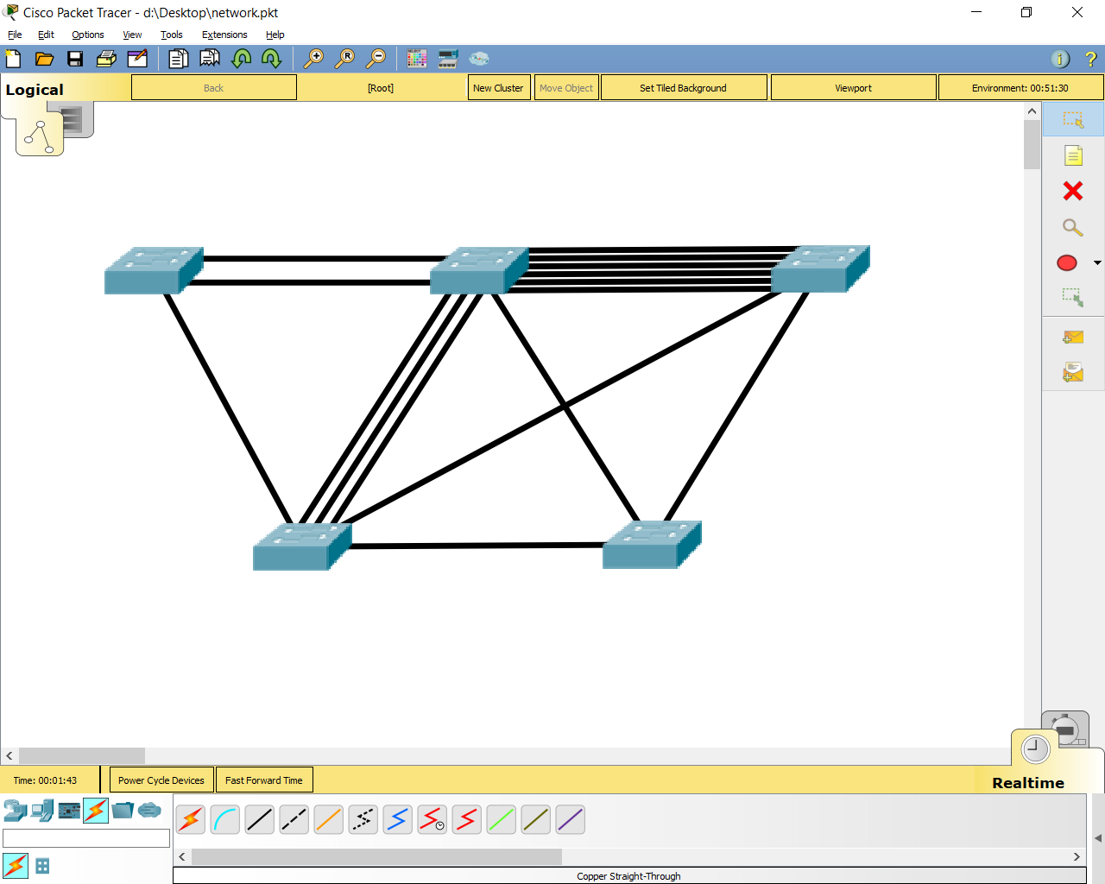
S4 S5
S1 F0/1-2 F0/3-4 S2 F0/5-10 F0/11-16 S3
F0/17 0/18-20 G0/1 G0/2 F0/24
F0/21 F0/22 G0/1
F0/1-3
F0/23
G0/1 G0/2

Port Cost
Link Speed | Cost |  | Link Speed | Cost
10 Gb/s | 2 |  | 400 Mbps | 8
1Gb/s | 4 |  | 300 Mbps | 9
800 Mbps | 5 |  | 200 Mbps | 12
700 Mbps | 5 |  | 100 Mbps | 19
600 Mbps | 6 |  | 10 Mbps | 100
500 Mbps | 7

 | (a) | Determine the Bridge IDs of the switches S1, S2, S3, S4 and S5.
  Switch | Priority | MAC Address | Bridge ID
  S1 | 32768 | 1A10.23A5.7898
  S2 | 12288 | 0100.23A5.7898
  S3 | 20480 | 0100:2A35.7898
  S4 | 12288 | 0A10.23A5.7898
  S5 | 32768 | 0010:2A35.7898
 | (b) | State and briefly explain your reason(s) for which switch will be elected as the root bridge.
 | (c) | After the STP operations have converged for all switches, state which ports will be assigned as root port [R], designated port [D] and non-designated port [N] in the following table.
  Name of switch | Port number | Type of port
  S1 | F0/1-2
  S1 | F0/17
  S2 | F0/3-4
  S2 | F0/5-10
  S2 | F0/18-20
  S2 | G0/1
  S3 | F0/11-16
  S3 | F0/24
  S3 | G0/2
  S4 | F0/1-3
  S4 | F0/21
  S4 | F0/22
  S4 | G0/1
  S5 | F0/23
  S5 | G0/1
  S5 | G0/2
 | (d) | Assume all the switches in the above network is running rapid-PVST+. Identify any two advantages of using rapid-PVST+.
 | (e) | Write the commands to enable Portfast and bpduguard in a switch.

Q4. | This question is related to Inter-VLAN Routing.
 | (a) | What is the main difference between Router-on-a-stick and Multi-layer Switching in Inter-VLAN routing?
 | (b) | List and describe the three different types of Layer 3 Interface of a Catalyst multilayer switch.
 | (c) | What is the advantages and disadvantages of using Switch Virtual Interfaces in InterVLAN routing.
 | (d) | Write the commands to configure a Layer 3 Etherchannel with the following setting:  Channel Group Number: 1  Port included in the Channel: F0/1 – F0/5  IP Address: 192.168.1.1/24  Channel Protocol: PAgP
 | (e) | Write the command to verify the member port of a Etherchannel.

